**Cognizant_Digital Nurture 4.0_Deep Skilling**

**Products and Frameworks**

**Module 8 - Microservices with Spring Boot 3 and Spring Cloud**

**Creating Microservices for account and loan**

**AccountController.java**

package com.cognizant.account;

import org.springframework.web.bind.annotation.*;

*@RestController*

*@RequestMapping*("/accounts")

public class AccountController {

*@GetMapping*("/{number}")

public Account getAccount(*@PathVariable* String number) {

return new Account(number, "savings", 234343);

}

record Account(String number, String type, double balance) {}

}

**AccountApplication.java**

package com.cognizant.account;

import org.springframework.boot.SpringApplication;

import org.springframework.boot.autoconfigure.SpringBootApplication;

@SpringBootApplication

public class AccountApplication {

public static void main(String[] args) {

SpringApplication.run(AccountApplication.class, args);

}

}

**Output:**

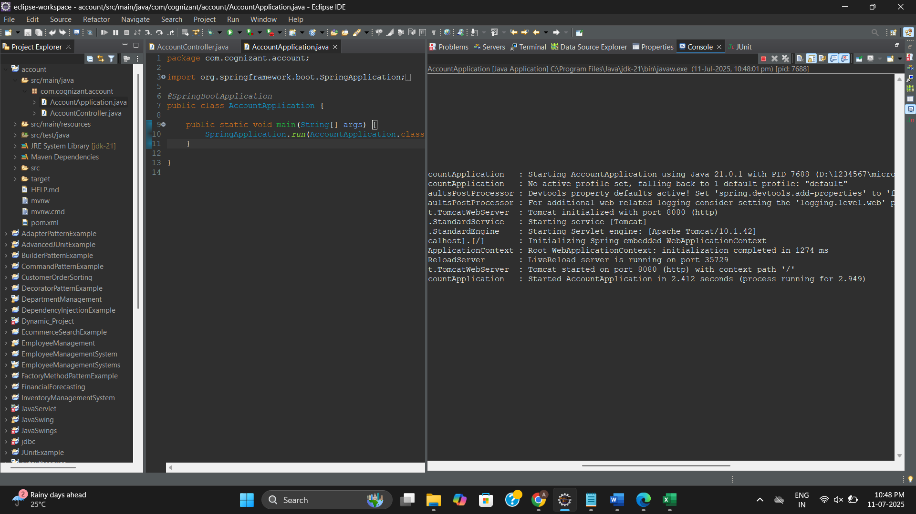

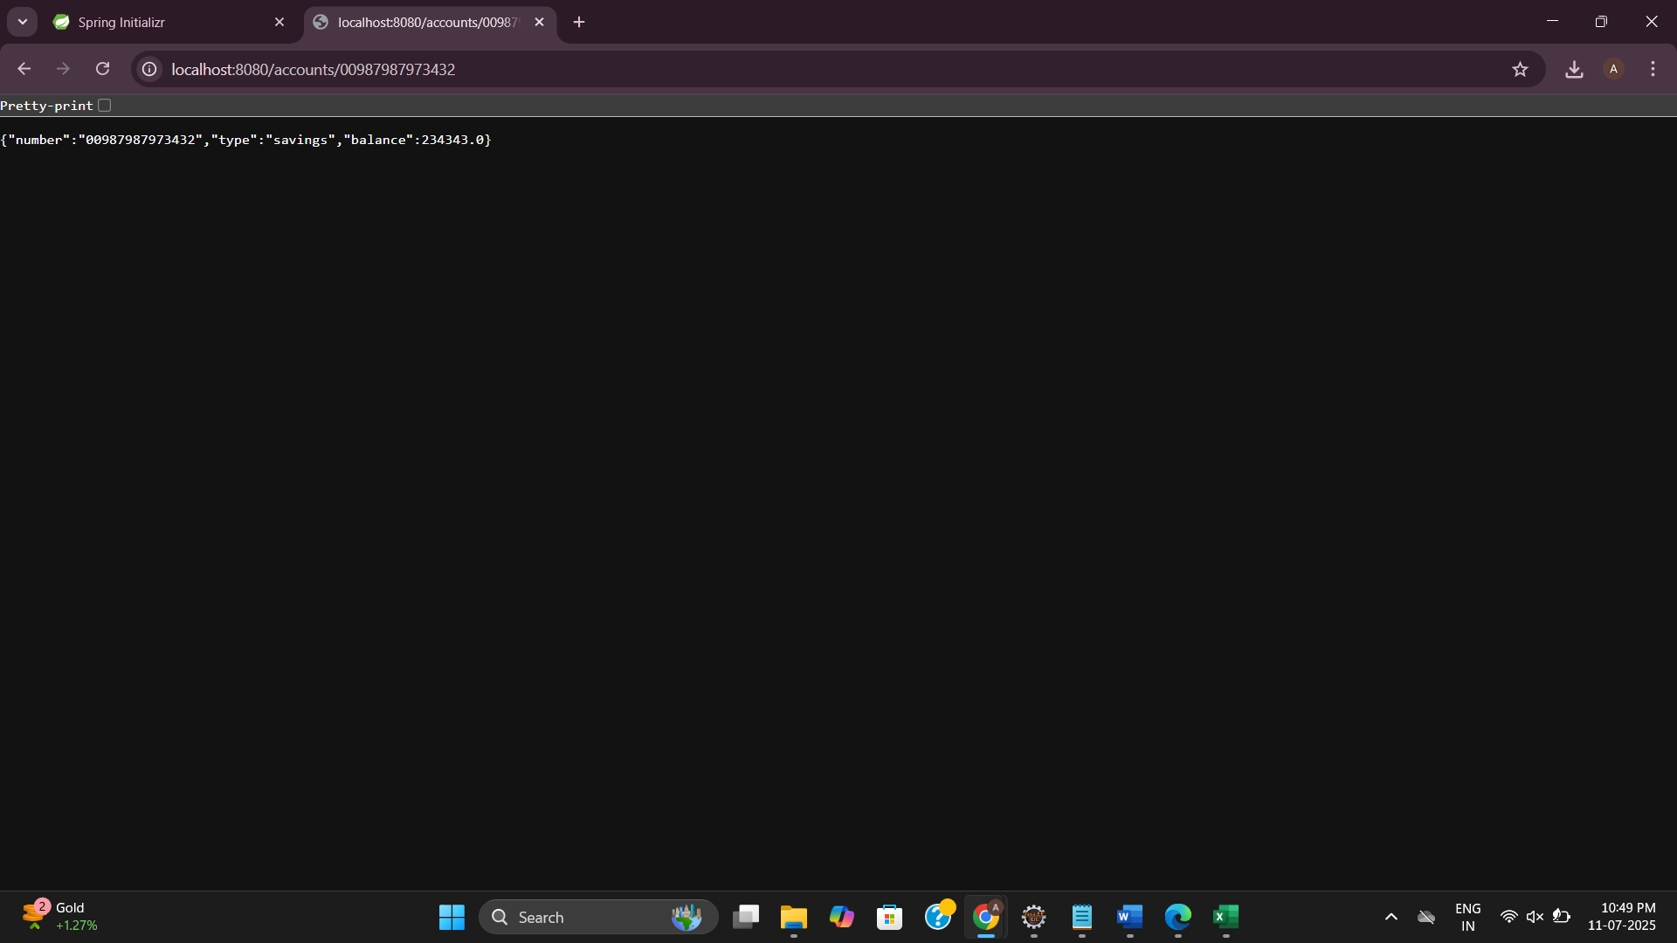

**LoanController.java**

package com.cognizant.loan;

import org.springframework.web.bind.annotation.*;

*@RestController*

*@RequestMapping*("/loans")

public class LoanController {

*@GetMapping*("/{number}")

public Loan getLoan(*@PathVariable* String number) {

return new Loan(number, "car", 400000, 3258, 18);

}

record Loan(String number, String type, double loan, int emi, int tenure) {}

}

**LoanApplication.java**

package com.cognizant.loan;

import org.springframework.boot.SpringApplication;

import org.springframework.boot.autoconfigure.SpringBootApplication;

@SpringBootApplication

public class LoanApplication {

public static void main(String[] args) {

SpringApplication.run(LoanApplication.class, args);

}

}

**Output:**

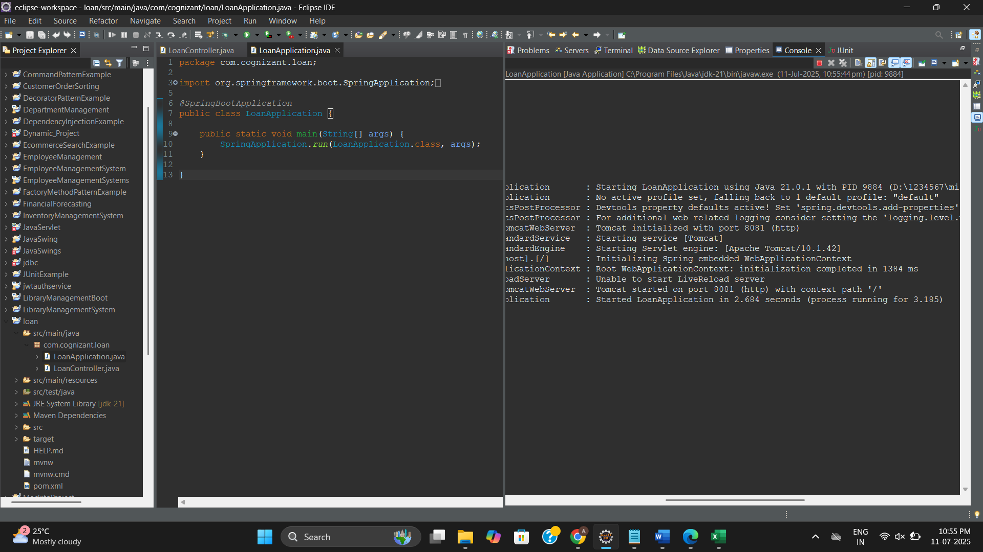

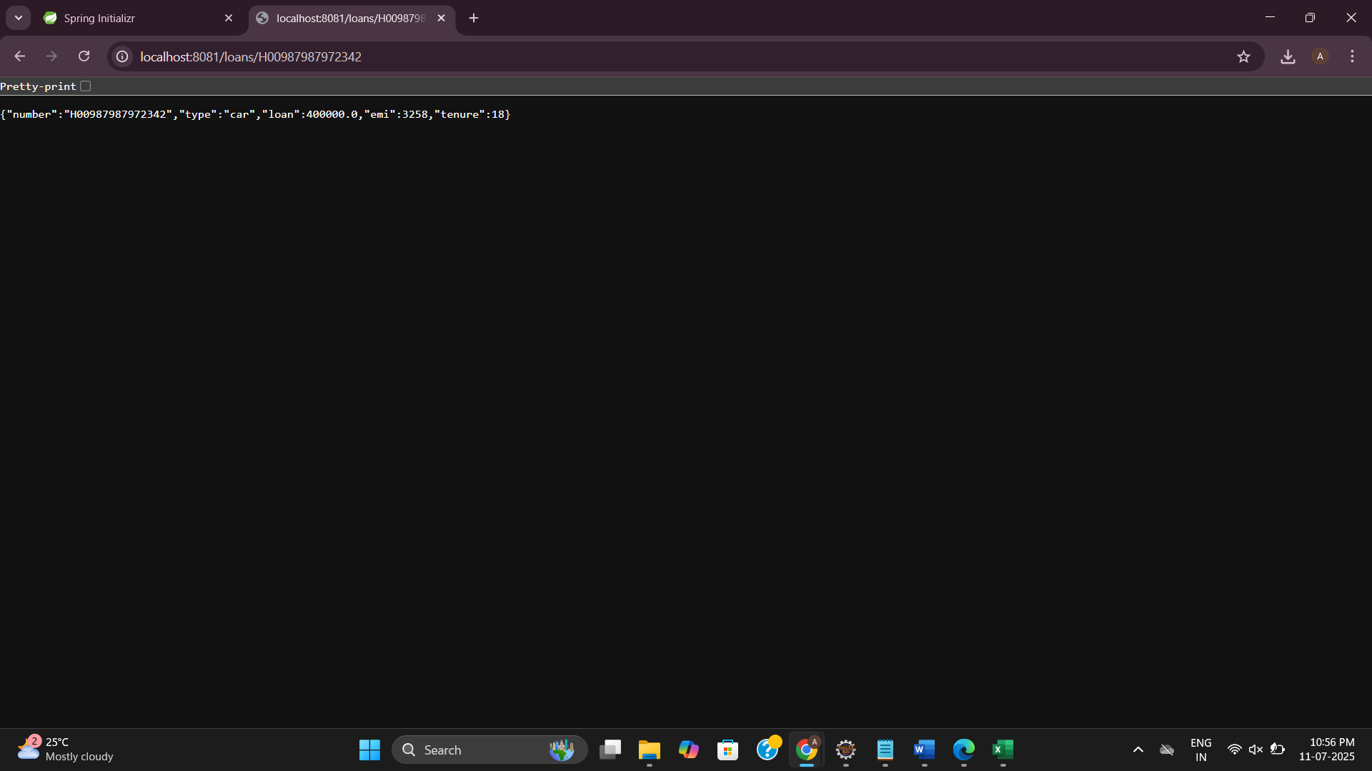

**Create Eureka Discovery Server and register microservices**

**eurekadiscoveryserver**

**EuekadiscoveryserverApplication.java**

package com.cognizant.eurekadiscoveryserver;

import org.springframework.boot.SpringApplication;

import org.springframework.boot.autoconfigure.SpringBootApplication;

import org.springframework.cloud.netflix.eureka.server.EnableEurekaServer;

@SpringBootApplication

@EnableEurekaServer // Add this annotation

public class EurekadiscoveryserverApplication {

public static void main(String[] args) {

SpringApplication.runspring.application.name=eurekadiscoveryserver(EurekadiscoveryserverApplication.class, args);

}

}

**application.properties**

spring.application.name=eurekadiscoveryserver

server.port=8761

eureka.client.register-with-eureka=false

eureka.client.fetch-registry=false

logging.level.com.netflix.eureka=OFF

logging.level.com.netflix.discovery=OFF

**AccountApplication.java**

package com.cognizant.account;

import org.springframework.boot.SpringApplication;

import org.springframework.boot.autoconfigure.SpringBootApplication;

import org.springframework.cloud.client.discovery.EnableDiscoveryClient;

@SpringBootApplication

@EnableDiscoveryClient

public class AccountApplication {

public static void main(String[] args) {

SpringApplication.run(AccountApplication.class, args);

}

}

**AccountController.java**

package com.cognizant.account.controller;

import org.springframework.web.bind.annotation.GetMapping;

import org.springframework.web.bind.annotation.RestController;

@RestController

public class AccountController {

@GetMapping("/account")

public String getAccountDetails() {

return "Account Service is working!";

}

}

**application.properties**

spring.application.name=account-service

server.port=8081

eureka.client.service-url.defaultZone=http://localhost:8761/eureka

**LoanApplication.java**

package com.cognizant.loan;

import org.springframework.boot.SpringApplication;

import org.springframework.boot.autoconfigure.SpringBootApplication;

import org.springframework.cloud.client.discovery.EnableDiscoveryClient;

@SpringBootApplication

@EnableDiscoveryClient

public class LoanApplication {

public static void main(String[] args) {

SpringApplication.run(LoanApplication.class, args);

}

}

**LoanController.java**

package com.cognizant.loan.controller;

import org.springframework.web.bind.annotation.GetMapping;

import org.springframework.web.bind.annotation.RestController;

@RestController

public class LoanController {

@GetMapping("/loan")

public String getLoan() {

return "Loan Service is working!";

}

}

**application.properties**

spring.application.name=loan-service

server.port=8082

eureka.client.service-url.defaultZone=http://localhost:8761/eureka

spring.application.name=loan

**apigateway**

**ApigatewayApplication.java**

package com.cognizant.apigateway;

import org.springframework.boot.SpringApplication;

import org.springframework.boot.autoconfigure.SpringBootApplication;

import org.springframework.cloud.client.discovery.EnableDiscoveryClient;

@SpringBootApplication

@EnableDiscoveryClient

public class ApigatewayApplication {

public static void main(String[] args) {

SpringApplication.run(ApigatewayApplication.class, args);

}

}

**application.properties**

spring.application.name=api-gateway

server.port=9090

eureka.client.service-url.defaultZone=http://localhost:8761/eureka

spring.cloud.gateway.discovery.locator.enabled=true

spring.cloud.gateway.discovery.locator.lower-case-service-id=true

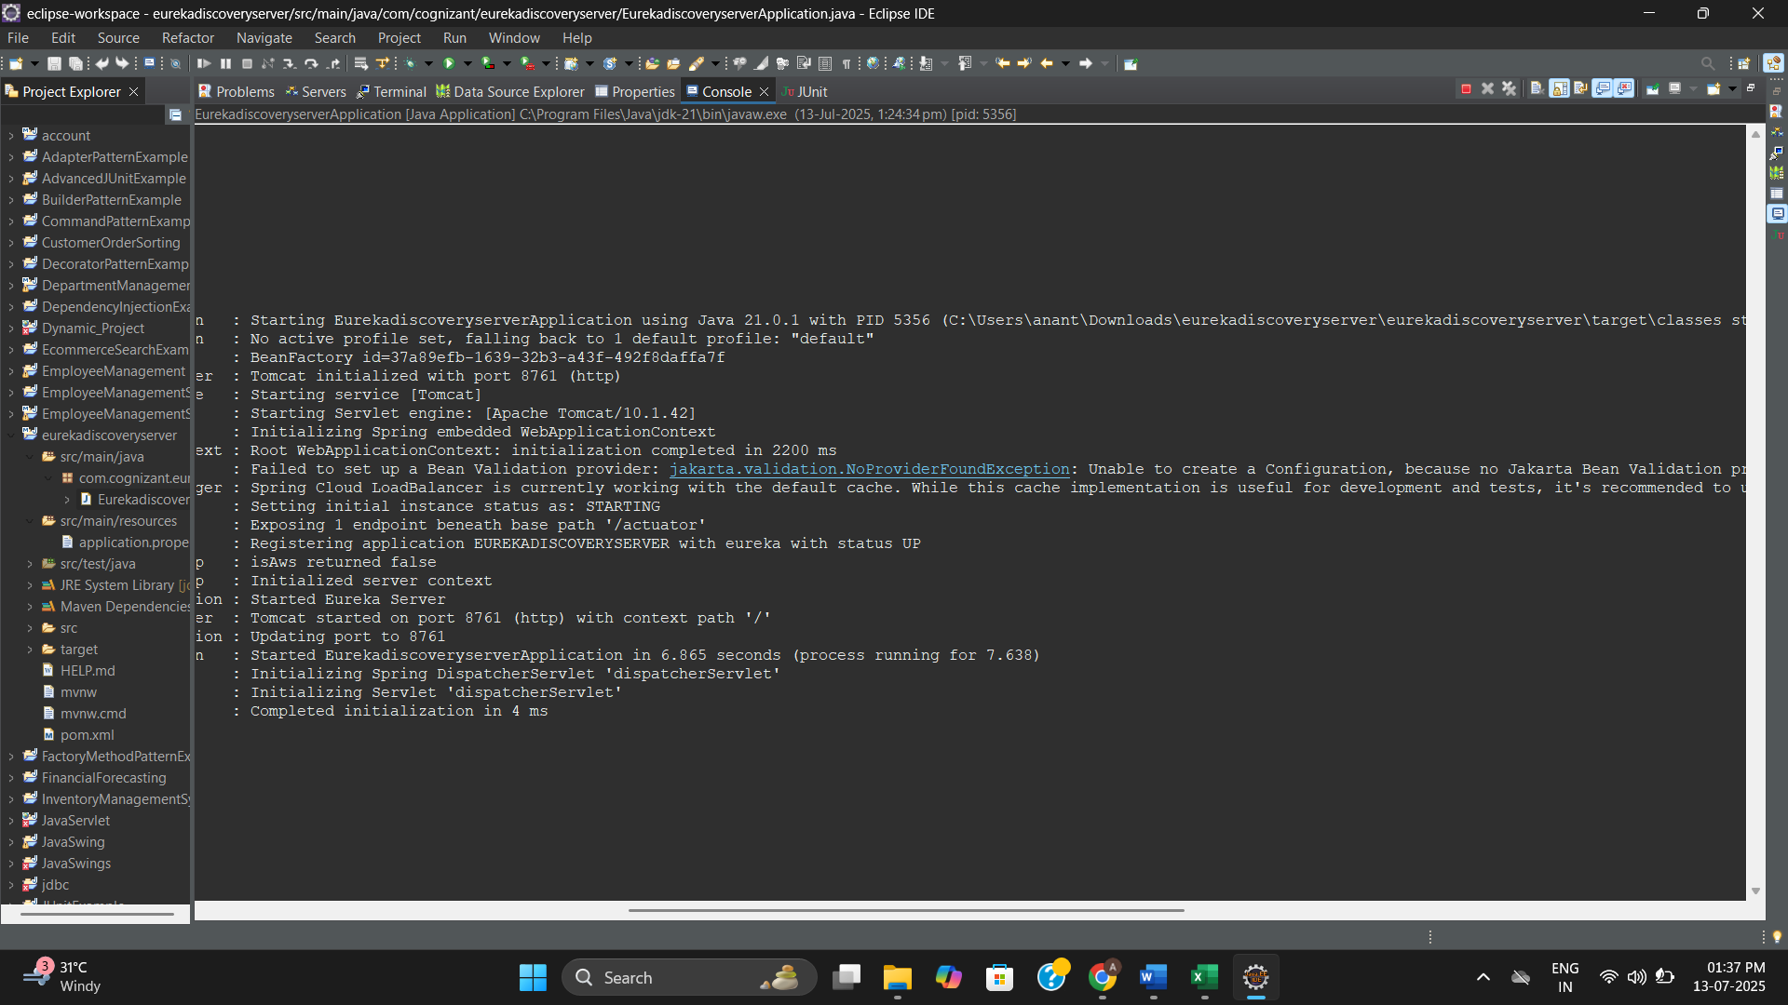

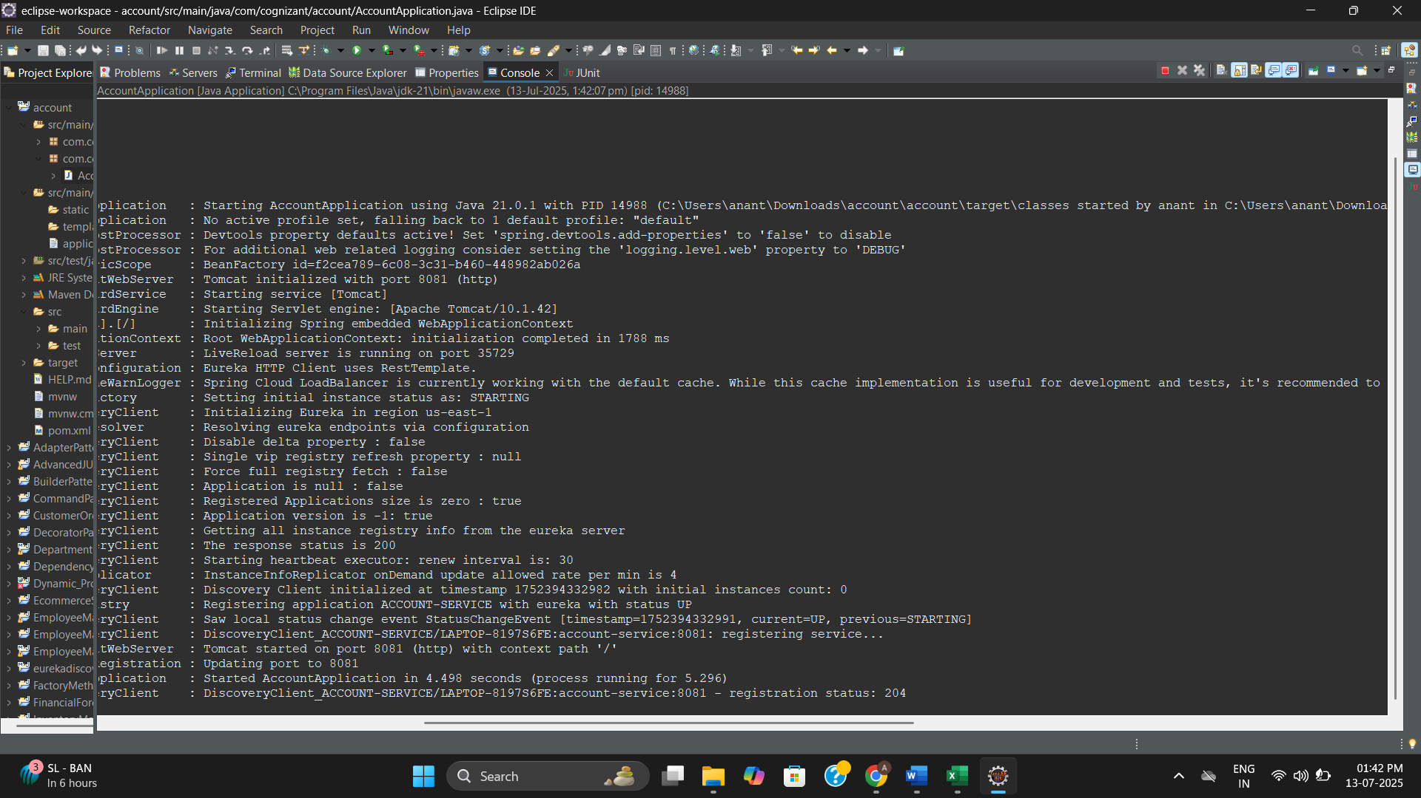

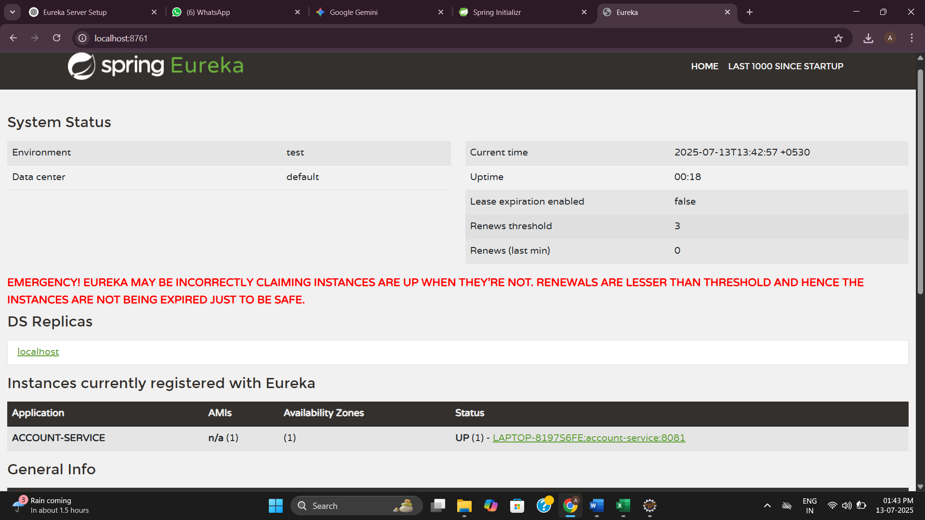

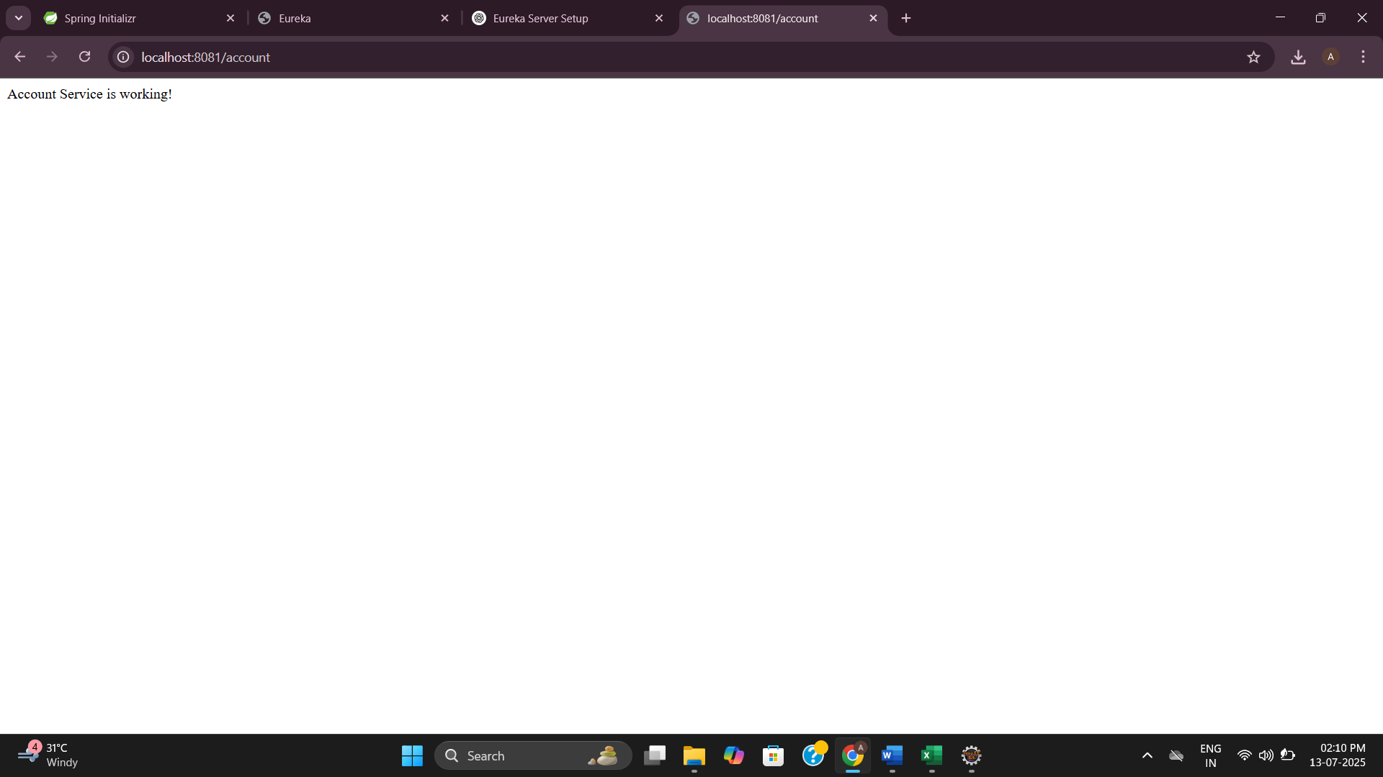

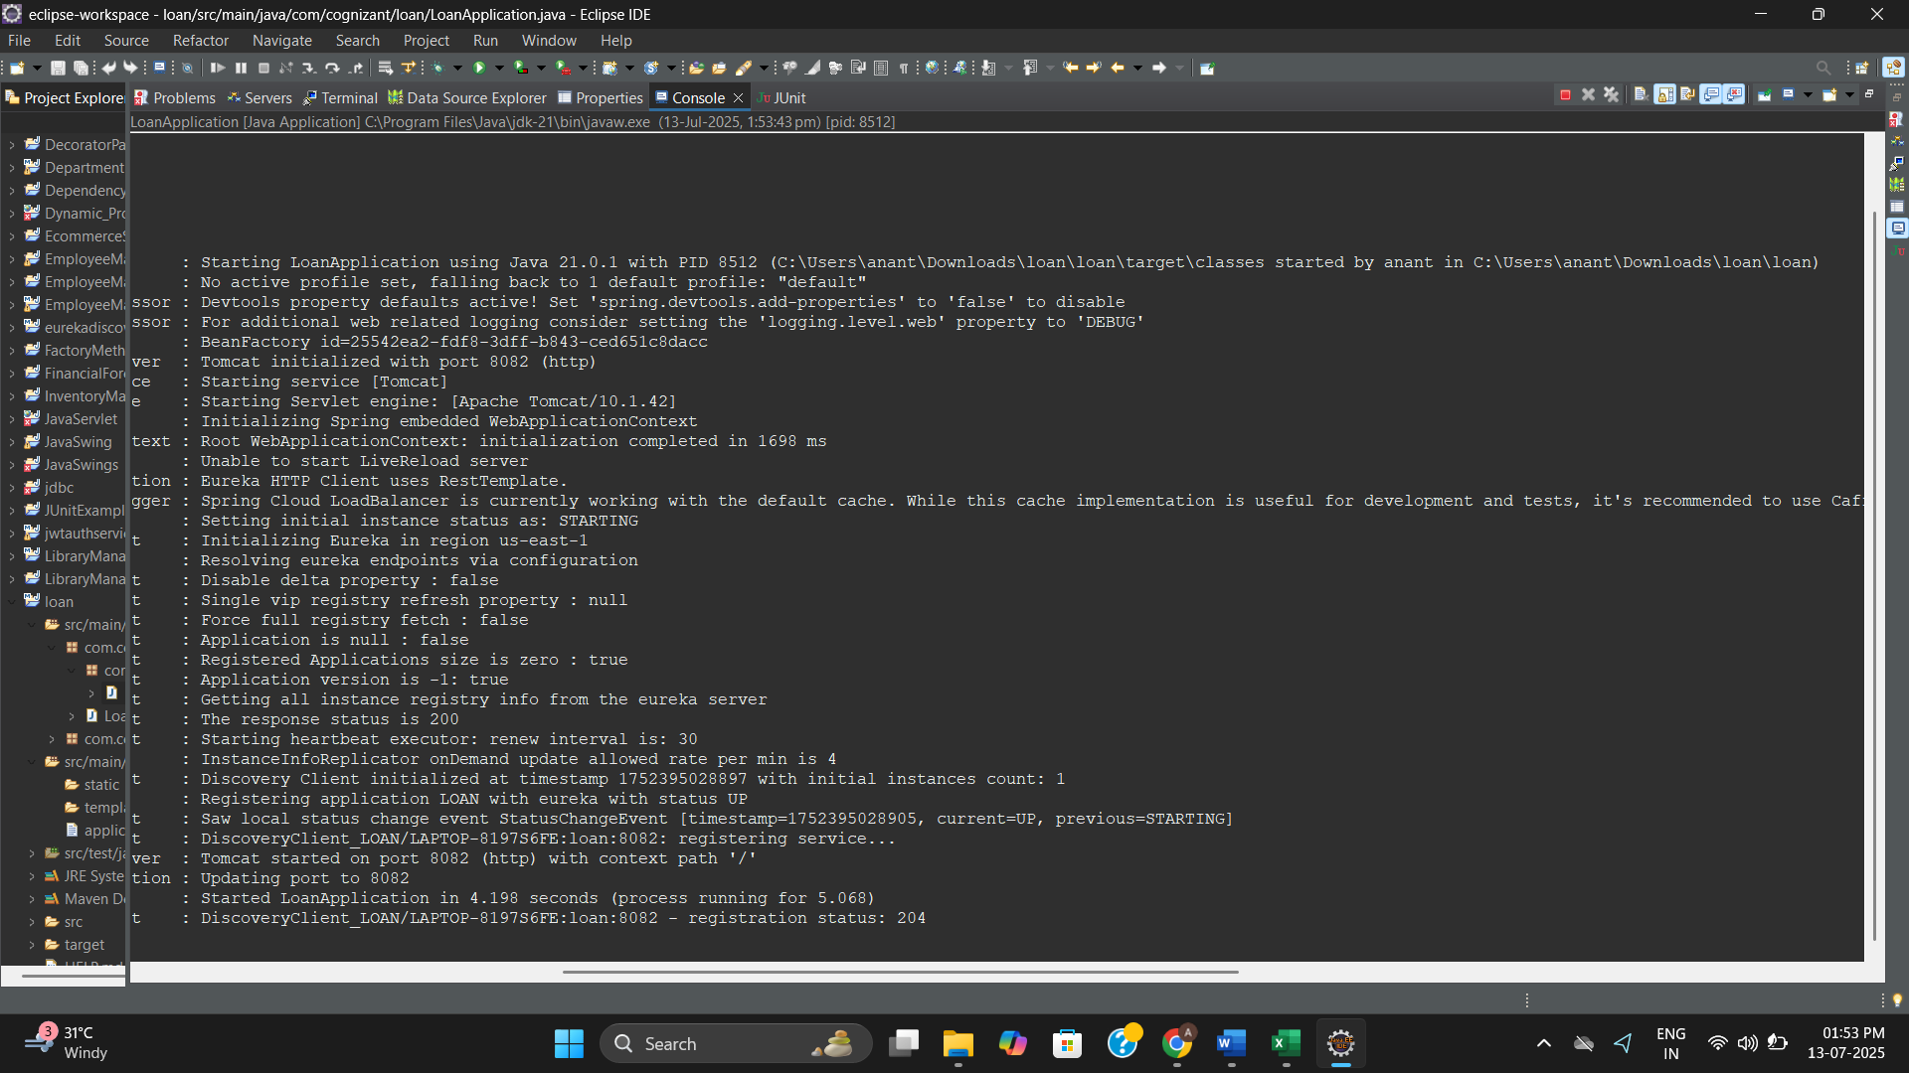

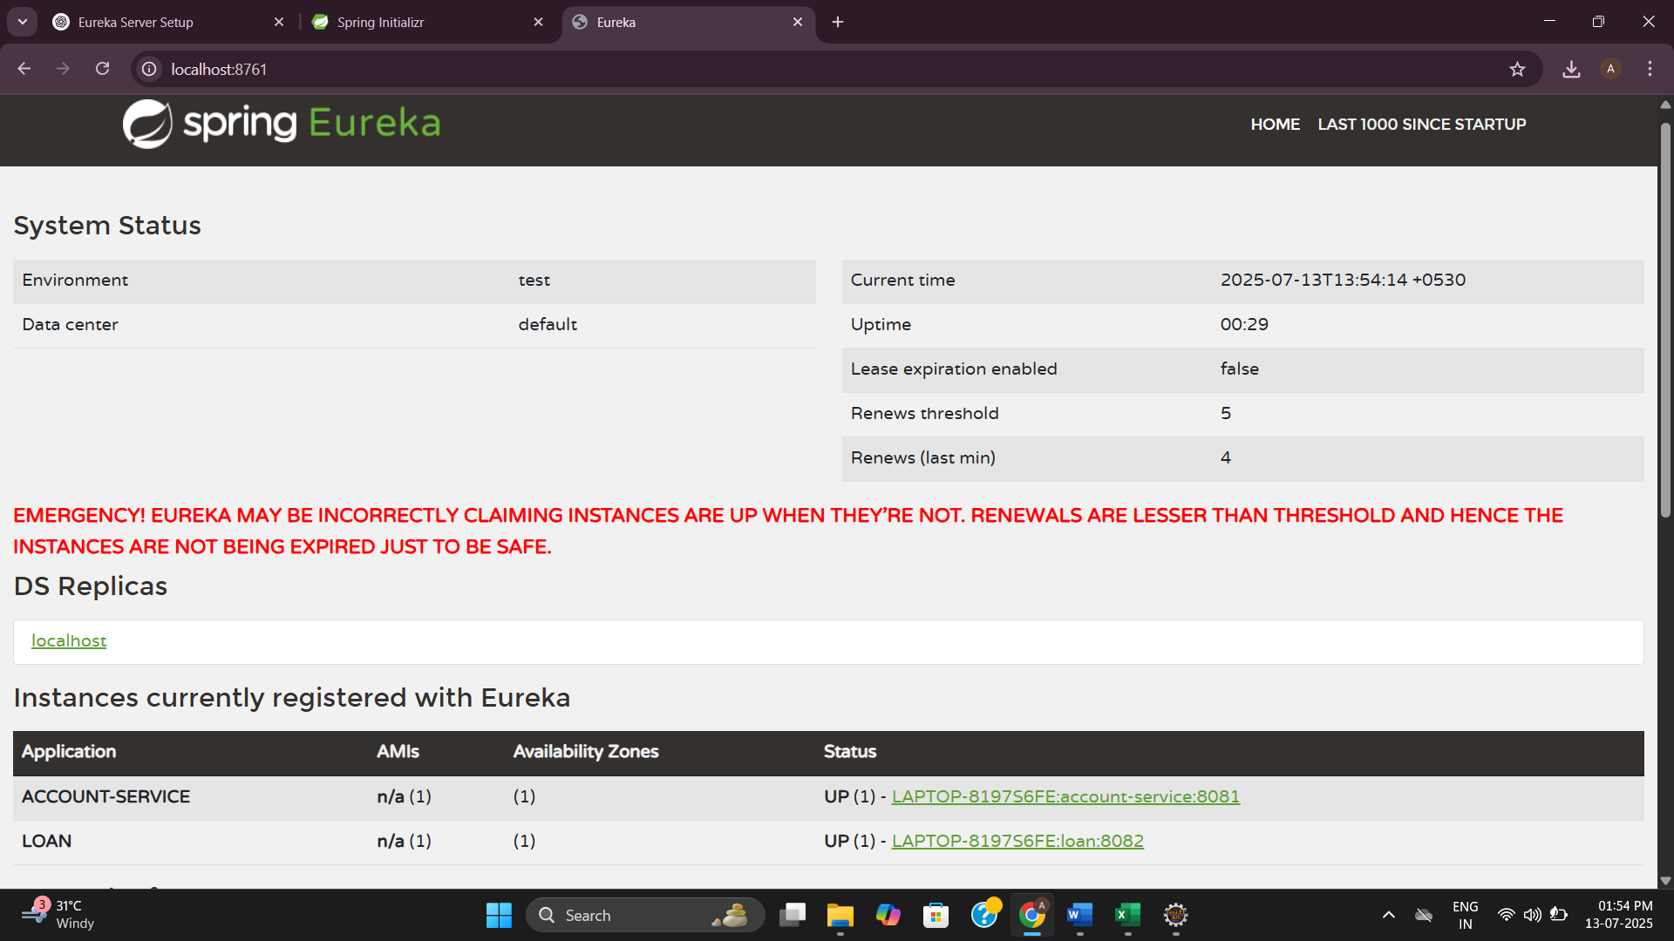

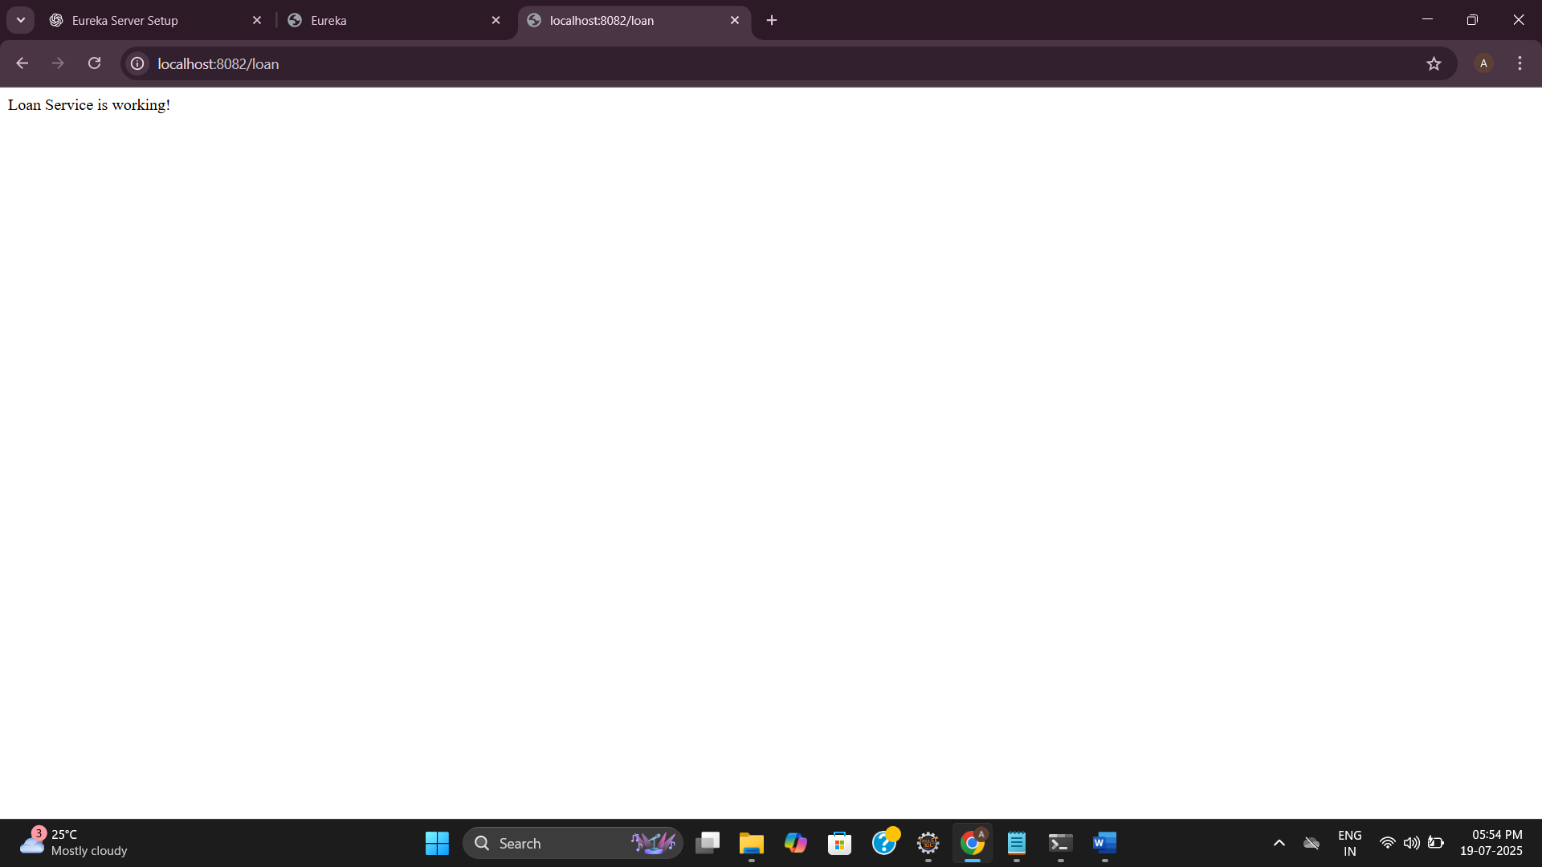

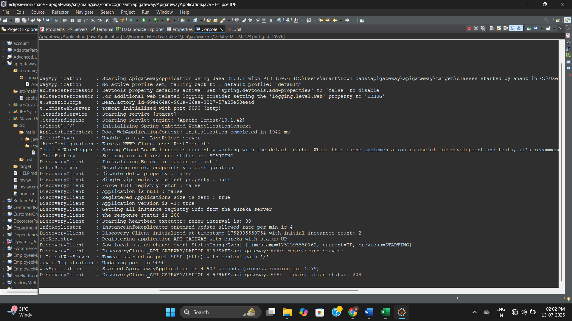

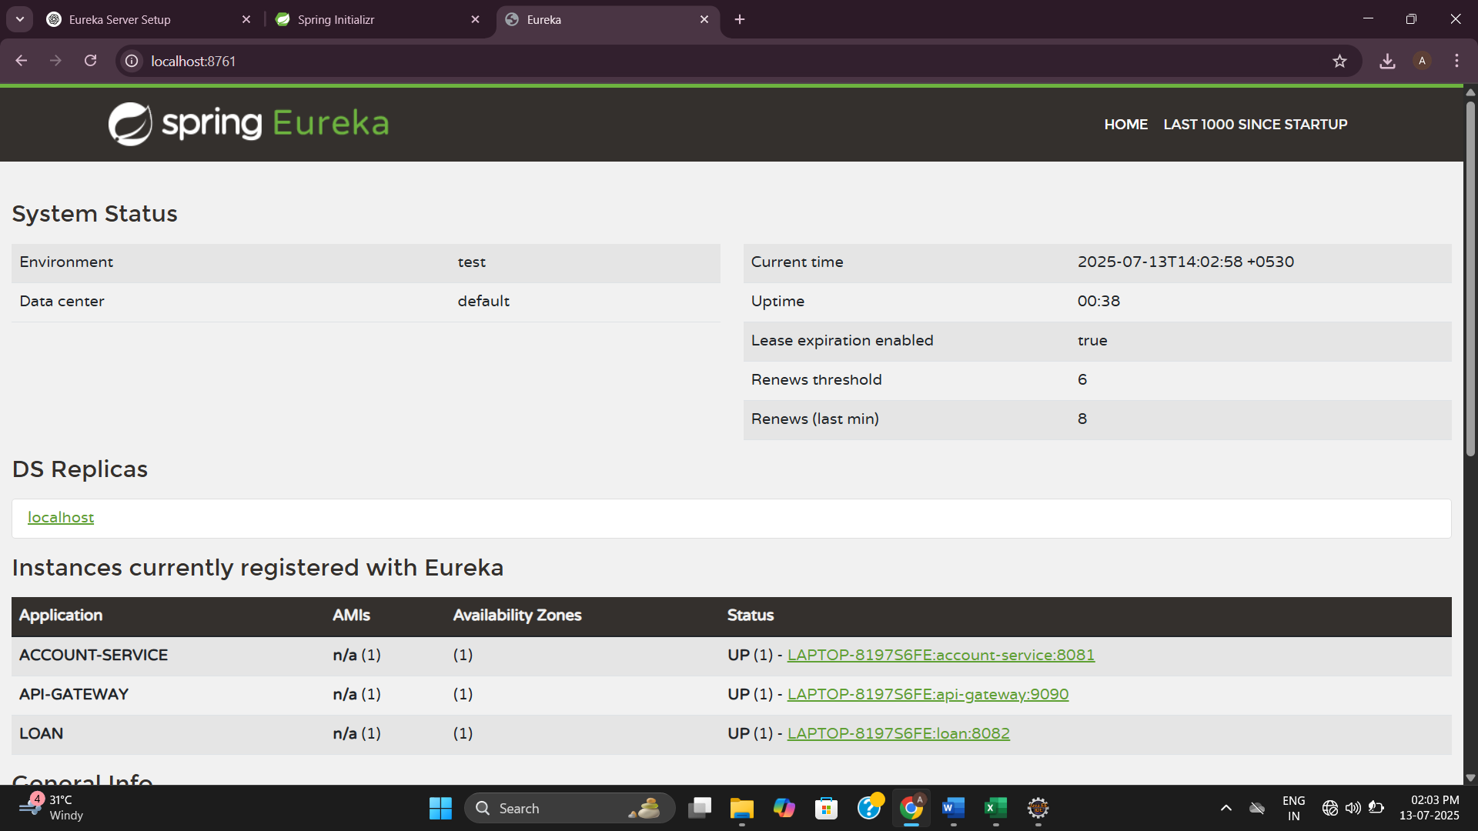

**After running all the codes**

